University Institute of Information Technology

PMAS-Arid Agriculture University, Rawalpindi



Project Proposal

For

**Product Lifecyle Management**

**Submitted By:**

Abdullah Talat

18-ARID-2595

Sharjeel Wakeel

18-ARID-2709

**Supervised By:**

Mr. Zeeshan Javed

Submission Date (27-10-2021)

Original Version: 1.0v

Project ID: ___________

(ID will be assigned by coordinator)

* **Please select the appropriate category of your project** *(Select multiple if required)*

**A-**Desktop Application/Information System **🞏** **B-**Problem Solving and AI **🞏**

**C-**Web Application/Web Application based Information System. **◼ D-**Simulation & Modeling **🞏**

**E-**Smartphone Application **🞏 F-**Smartphone Game **🞏**

**G-**Image Processing **🞏** **H-**Networks **🞏**

**I-** Other: ____________________________________ **🞏**

**Group Members**

1. Student Name: Abdullah Talat

Registration No: 18-Arid-2595

Class: BSCS

Section: A

Shift: Evening

Email: abdullahqureshi8055@gmail.com

WhatsApp No: 03160518801

1. Student Name: Sharjeel Wakeel

Registration No: 18-Arid-2709

Class: BSCS

Section: A

Shift: Evening

Email: sharjeelwakeel837@gmail.com

WhatsApp No: 03151236401

**table of contents**

1.introduction4

2.literature review4

3.problem statement4

4.problem solution4

5.advantage 4

6.scope4

7.module4

8.software methodology5

9.tools and technology6

10.concept6

11.intend user6

12.mockups7

13.CONCLUSION8

## Introduction we make a project where we hold a project and product. We analyze that what cost occur on a project which risk factor we face during deployment how to we increase the quality of the product and what resource we need to accomplish our task. We also check the feasibility of a product. In existence system we faced configuration problem even developer don’t able to create account or manage his project. He needs some training then he able to use those system. He tries to overcome this issue through our project.

## Literature Review

**Flinkiso** is an existing system in which we manage, audit the project. We also assure project quality but this platform has a problem which is that its configuration is quite tough event developer don’t able to configure their project management is a challenge

**Jirasoftware** is another existing system which is used for issue tracking and project management by over 180,000 customers in 190 countries. Some of the organizations that have used Jira at some point in time for bug-tracking and project management include Fedora Commons, Hibernate, and the Apache Software Foundation.

## Problem Statement

The existing platform is good but their configuration is too tough and also developer faced difficulty in use. They need some training to use these platforms. In these platform product management is too complex. So, in our project we provide easy configuration and user-friendly management environment.

## Problem Solution

We overcome discussing issue with a solution which is that we provide easy configuration and user-friendly environment where they manage their product and don’t face problem which they faced in existing system and they don’t need to take training for using this system.

## 5.Advantages/Benefits of proposed system

* Easy configuration
* User-friendly environment
* Don’t need training

## 6.Scope

Developer check feasibility of a product and assure the quality of a product manage the risk, concern with stakeholders, schedule the product, integrate new functionality, declare the scope and find the resources for a product.

**Modules of the project:**

1**.Feasibility Study**

In feasibility study we check that we able to do that we have resources to accomplish the task. Discussing problem have any possibility to overcome.

**2.Project proposal and Review**

**1.Project Integration Management**

The purpose of project integration management is to ensure that processes run efficiently and meet predefined goals.

**2.Project Scope Management**

Project scope management refers to the total amount of work that must be done in order to deliver a product, service, or result with specified functions and feature.

**3.Project Schedule Management**

Scheduling in project management is the listing of activities, deliverables, and milestones within a project. A schedule also usually includes a planned start and finish date, duration, and resources assigned to each activity.

**4.Project Cost Management**

Cost management in project management is the process of planning, estimating, budgeting, and controlling project costs. Cost management processes are in place to help project teams plan and control budgets during the project life cycle.

**5.Project Quality Management**

Project quality management is the process of continually measuring the quality of all activities and taking corrective action until the desired quality is achieved.

**6.Project Resource Management**

Resource management is an aspect of the project management process that plans, organizes, manages, and measures people's work. Its purpose is to plan, allocate and schedule the company's resources as efficiently as possible.

**7.Project Communication Management**

Project communication management is a collection of processes that help make sure the right messages are sent, received, and understood by the right people.

**8.Project Risk Management**

Risk management is the practice of identifying, evaluating, and preventing or mitigating risks to a project that have the potential to impact the desired outcomes.

**9.Project Procurement Management**

Procurement Project Management is a structured process that is used to define, plan, implement, control and transition an activity from a current to a future state.

**10.Project Stakeholder Management**

Stakeholder management is the process by which you organize, monitor and improve your relationships with your stakeholders. It involves systematically identifying stakeholders; analyzing their needs and expectations; and planning and implementing various tasks to engage with them.

## 7.Software Methodology

We used Agile methodology for development because in this method we work in supervision so we need satisfaction of supervision if he not satisfied then this method allows to work on that module and the other reason of using this method in future if we have new requirements then easily address these requirements and implement.

## 8.Tools and Technologies

|  |  |  |
| --- | --- | --- |
| **Tools**  **And**  **Technologies** | **Tools** | **Version** |
| Visual Studio code | 64 bit |
| MS SQL Server | 2012 |
| Adobe Illustrator | 2019 |
| MS Word | 2016 |
| MS Power Point | 2016 |
| **Technology** | **Version** |
| PHP | 8.0 |
| MySQL | 2011 |
| Html | 5 |
| JavaScript | ES2015 |
| CSS | 3 |
| Bootstrap | 5.1 |

## 9.Concepts

We learn from this project how to manage a lot of data and how to make a flow of big project. We also learn adobe illustrator for making logo of website.

## 10. Intended Users

The Intend user of our project is a developer who know any language and want to develop something in every domain.

## 11. Mockups

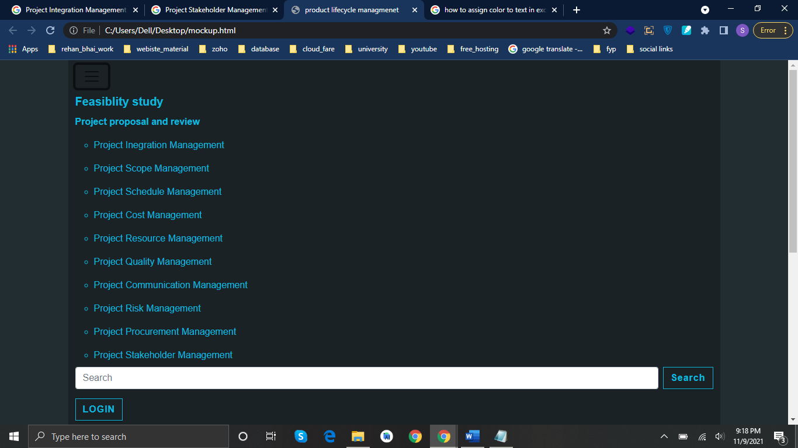

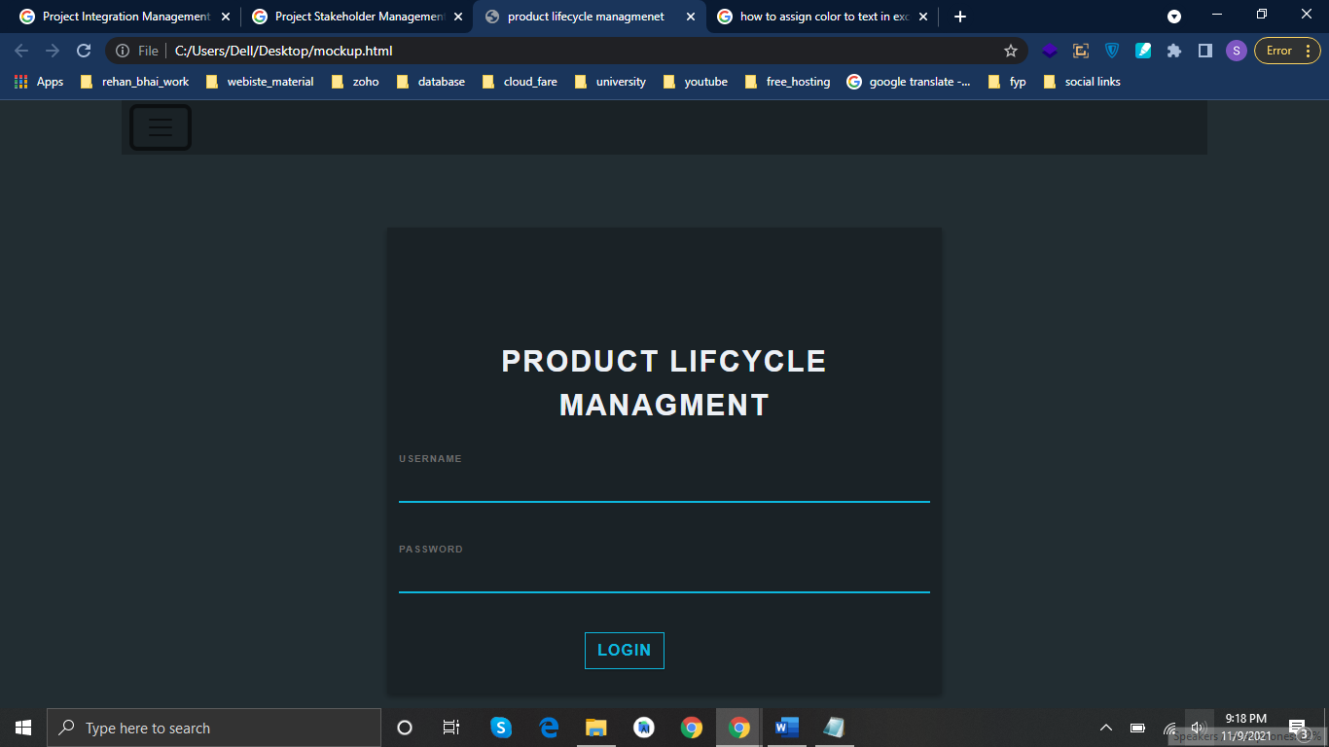

## 12. Timeline

.

Requirement

November 2021

Analysis

December 2021

Design

February 2022

Development

April 2022

Testing & Deployment

May 2022

Final Evaluation

June 2022

## 13. Conclusion

The existing platform is good but their configuration is too tough and also developer faced difficulty in use. They need some training to use these platforms. So, we provide easy configuration and user-friendly environment where they manage their product and don’t face problem which they faced in existing system and they don’t need to take training for using this system

## 14. References

<https://cloud.flinkiso.com/register/users/>

<https://atlassian.com/software/jira>

**Evaluation Page**

**Evaluator 1**

**Comments:** ____________________________________________________________

_________________________________________________________________________________

_________________________________________________________________________________

_________________________________________________________________________________

_________________________________________________________________________________

_________________________________________________________________________________

_____________

Signatures

**Evaluator 2 Comments:**____________________________________________________________

_________________________________________________________________________________

_________________________________________________________________________________

_________________________________________________________________________________

_________________________________________________________________________________

_________________________________________________________________________________

_____________

Signatures

**Project Coordinator Comments**_____________________________________________________

_________________________________________________________________________________

_________________________________________________________________________________

_________________________________________________________________________________

_________________________________________________________________________________

_________________________________________________________________________________

_________________________________________________________________________________

_____________

Signatures